**North Western University, Khulna**



**Project Title: Networking at University**

**Course Title: Computer Networking Sessional**

**Course code: CSE-3304**

**Department: Computer Science and Engineering**

**Student Name & ID:**

|  |  |
| --- | --- |
| **Student Name** | **Student ID** |
| **Sajib Bhattacjarjee** | **20201070010** |

**Name of the course teacher: Abu Naim Khan.**

**Remarks:**

**Executive Summary**

Computer networks have a significant impact on the working of an organization. Universities depend on the proper functioning and analysis of their networks for education, administration, communication, e-library, automation, etc. An efficient network is essential to facilitate the systematic and cost-efficient transfer of information in an organization in the form of messages, files, and resources. The project provides insights into various concepts such as topology design, IP address configuration, and how to send information in the form of packets to the wireless networks of different areas of a University.

Campus networking via wireless connection becomes an important part of campus life and provides the main way for teachers and students to access educational resources, which gives an important platform to exchange information. As laptops and intelligent terminals are widely used, demand for access to information anytime and anywhere has become more and more urgent, but traditional cable networks cannot meet this requirement. Then wireless network construction becomes necessary and essential. The wireless network is one of the important components of a digital campus and wisdom campus. It provides an efficient way to explore the internet with a mobile terminal for teachers and students regardless of cables and places. This is an important mark of the modern campus as a supplement of a cable network. With the development of network and communication technology, cable networks on a university campus bring much convenience for teaching and research work. But for mobility and flexibility, it has obvious shortcomings. A wireless network can overcome these drawbacks and has been applied to the university campus.

**Table of Contents page no**

**1. Introduction**

1.1. Goals and Objectives of the project  ~~------------------------------------------------- 03~~

1.2. Terms, Acronyms, and Abbreviations Used ----------------------------------------- 04

**2. Description**

2.1. Details Explanation ------------------------------------------------------------------- 04

2.2. Technology, software, and hardware used----------------------------------- 08

**3. Discussion --------------------------------------------------------------------------- 10**

**List of Figure Page No.**

|  |  |  |
| --- | --- | --- |
| 1. | University Networking System | 05 |

**List of Tables**

We did not use any table content in our project.

**1. INTRODUCTION**

1.1. Goals and Objectives of the project

Packet Tracer is a cross-platform visual simulation tool designed by Cisco Systems that allows users to create network topologies and imitate modern computer networks. The software allows users to simulate the configuration of Cisco routers and switches using a simulated command-line interface. Packet Tracer makes use of a drag-and-drop user interface, allowing users to add and remove simulated network devices as they see fit. The software is mainly focused on Certified Cisco Network Associate Academy students as an educational tool for helping them learn fundamental CCNA concepts. Previously students enrolled in a CCNA Academy program could freely download and use the tool free of charge for educational use.

Computing devices are the electronic devices that take user inputs, process the inputs, and then provide us with the end results. These devices may be Smartphones, PC Desktops, Laptops, printer, and many more.

The simulations of our network topology can be easily achieved using cisco packet tracer. Using a simulation mode, you can see packets flowing from one node to another and can also click on a packet to see detailed information about the OSI layers of the networking. Packet Tracer offers a huge platform to combine realistic simulation and visualize them simultaneously. Cisco Packet Tracer makes learning and teaching significantly easier by supporting multi-user collaboration and by providing a realistic simulation environment for experimenting with projects.

**1.2. Terms, Acronyms, and Abbreviations Used**

Abbreviations

MSE-Mobility Service Engine

UCS- Unified Computing System

RFP- Request For Proposal

IP -Internet Protocol

RIP -Routing Information Protocol

RPP- Routing Protocol Plan

OS- Operating System

OSI- Open Systems Interconnection

FTP- File Transfer Protocol

DNS- Domain Name System

LAN- Local Area Network

VLAN- Virtual Local Area Network

**2.1 Detailed explanation.**

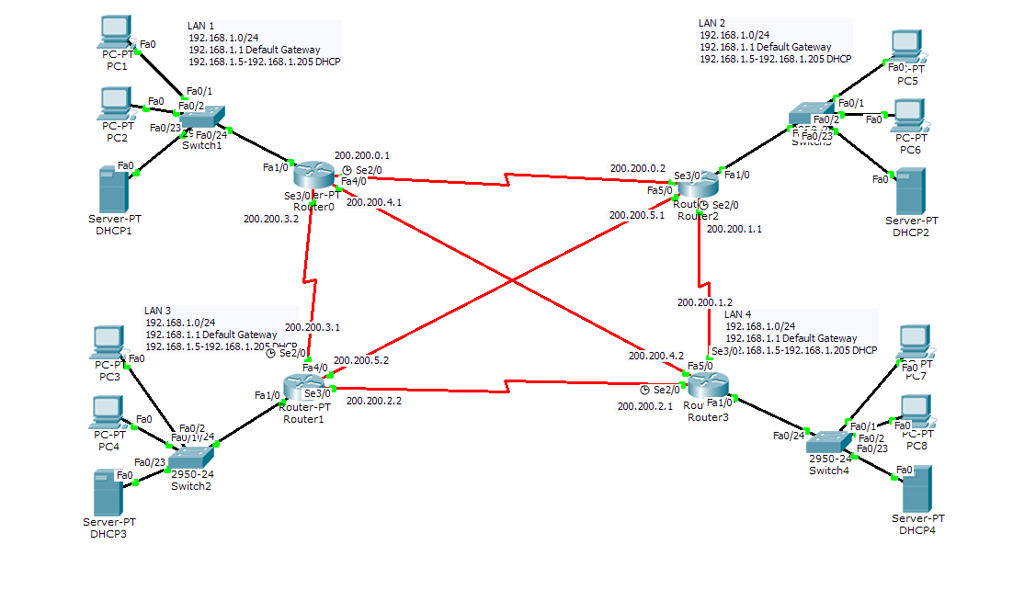

**Fig name: University Network System**

The software allows users to simulate the configuration of Cisco routers and switches using a simulated command-line interface. Packet Tracer makes use of a drag-and-drop user interface, allowing users to add and remove simulated network devices as they see fit. The software is mainly focused on Certified Cisco Network Associate Academy students as an educational tool for helping them learn fundamental CCNA concepts. Previously students enrolled in a CCNA Academy program could freely download and use the tool free of charge for educational use.

* Router

A router is a device like a switch that routes data packets based on their IP addresses. The router is mainly a Network Layer device. Routers normally connect LANs and WANs together and have a dynamically updating routing table based on which they make decisions on routing the data packets. Router divides broadcast domains of hosts connected through it.

* SwitchA network switch (also called switching hub, bridging hub, officially MAC bridge is networking hardware that connects devices on a computer network by using packet switching to receive and forward data to the destination device. A network switch is a multiport network bridge that uses MAC addresses to forward data at the data link layer (layer 2) of the OSI model. Some switches can also forward data at the network layer (layer 3) by additionally incorporating routing functionality. Such switches are commonly known as layer-3 switches or multilayer switches.
* Network Packet

A network packet is a formatted unit of data carried by a packet-switched network. A packet consists of control information and user data, which is also known as the payload.

* Server : A server is a computer or system that provides resources, data, services, or programs to other computers, known as clients, over a network. In theory, whenever computers share resources with client machines they are considered servers. There are many types of servers, including web servers, mail servers, and virtual servers.

Many networks contain one or more of the common servers. The servers used in our project are as follows:

* DNS Server

DNS stands for Domain Name System servers which are application servers that provide a human-friendly naming method to the user computers in order to make IP addresses readable by users. The DNS system is a widely distributed database of names and other DNS servers, each of which can be used to request an otherwise unknown computer name. When a user needs the address of a system, it sends a DNS request with the name of the desired resource to a DNS server. The DNS server responds with the necessary IP address from its table of names.

* WEB Server

One of the widely used servers in today’s market is a web server. A web server is a special kind of application server that hosts programs and data requested by users across the Internet or an intranet. Web servers respond to requests from browsers running on client computers for web pages, or other web-based services.

* EMAIL Server

An e-mail server is a server that handles and delivers e-mail over a network, using standard email protocols. For example, the SMTP protocol sends messages and handles outgoing mail requests. The POP3 protocol receives messages and is used to process incoming mail. When you log on to a mail server using a webmail interface or email client, these protocols handle all the connections behind the scenes.

* Wireless Network

A wireless network broadcasts an access signal to the workstations or PCs. This enables mobility among laptops, tablets, and PCs from room to room while maintaining a firm network connection continuously. A wireless network also presents additional security requirements.

* Ethernet

This is the backbone of our network. It consists of the cabling and is typically able to

transfer data at a rate of 100mb/s. It is a system for connecting a number of computer systems to form a local area network, with protocols to control the passing of information and to avoid simultaneous transmission by two or more systems. Among the different types of ethernet, we have used Gigabit Ethernet, which is a type of Ethernet network capable of transferring data at a rate of 1000 Mbps and fast Ethernet is a type of Ethernet network that can transfer data at a rate of 100 Mbps.

* Computing Device
* Computing devices are the electronic devices that take user inputs, process the inputs, and then provide us with the end results. These devices may be Smartphones, PC Desktops, Laptops, printer, and many more.
* Internet Protocol

Internet Protocol (IP) is one of the fundamental protocols that allow the internet to work. IP addresses are a unique set of numbers on each network and they allow machines to address each other across a network. It is implemented on the internet layer in the IP/TCP model.

* SSH Protocol

Secure Shell enables a user to access a remote device and manage it remotely. However, with SSH, all data transmitted over a network (including usernames and passwords) isencrypted and secure from eavesdropping.

SSH is aclient-server protocol, with an SSH client and an SSH server. The client machine (such as a PC) establishes a connection to an SSH server running on a remote device (such as a router). Once the connection has been established, a network admin can execute commands on the remote device.

* Benefits of wireless networking over wired networking

To better understand the wide usage of wireless networking in today’s world, is to start with the benefits it has over traditional wired networking is crucial for our project implementation. Some major aspects have been stated below that show the various advantages of a wireless network over wired ones.

1. Mobility

One of the major advantages of wireless is mobility. Users have the freedom to move within the area of the network with their computing devices staying connected to a network without being concerned about the cable connection.

1. Less Hassle

The wireless network helps in the reduction of large amounts of cables or wires which becomes chaotic and difficult to maintain, it makes the connection hassle-free.

1. Accessibility

Provide network access across your organization, even in areas that have been challenging to reach with the wired network, so your entire team can stay in touch.

1. Expandability

The wireless network helps in the expansion of the network to a wide range by adding multiple new users and locations without additional need to run cables and wires.

1. Guest Access

Offer secure network access to guest users, including customers and business partners, while keeping your network resources protected.

With lots of advantages, there come disadvantages as well, like security issues which can be resolved using strict protection passwords. Also, the Speed of wireless networks is considered to be slow and having low bandwidth when compared to the direct cable connection networks.

* Simulation Environment

The simulations of our network topology can be easily achieved using cisco packet tracer. Using a simulation mode, you can see packets flowing from one node to another and can also click on a packet to see detailed information about the OSI layers of the networking. Packet Tracer offers a huge platform to combine realistic simulation and visualize them simultaneously. Cisco Packet Tracer makes learning and teaching significantly easier by supporting multi-user collaboration and by providing a realistic simulation environment for experimenting with projects.

**2.2. Technology, software, and hardware used**

**Technology:**

-Cisco Packet Tracer

**Software:**

- Operating System: Windows

- Cisco Packet Tracer

**Hardware Used:**

-Chipset: Intel CORE i5

- Storage:1 Tera Hard Disk, RAM-8GB

- Primary Display: QVGA TFT LCD or larger, 16 Bit color or Better

- Mouse

- Keyboard

**3. Discussion**

We started our discussion with the word “digitalization” and in order to achieve it, we aimed to start with an educational institute, and finally, we designed a network for a University, which is wireless. As we mentioned, mobility and efficiency are the key aspects of wireless networks, which were our main goal, and hence, we decided to shift to a wireless network instead of a wired one, making our network clean and less chaotic.

In this project, we designed a University Network using Cisco Packet Tracer that uses a networking topology implemented using servers, routers, switches, and end devices in a multiple area networks. We have covered all the necessary features that are required for a network to function properly. We have included a DNS server and a web server for establishing a smooth communication system between different areas of our network and specifically for the communication between students and teachers. We have included an email server to facilitate intra university communication through emails within the domain. We have used console passwords and ssh protocol to ensure a safe and secure transfer of data.